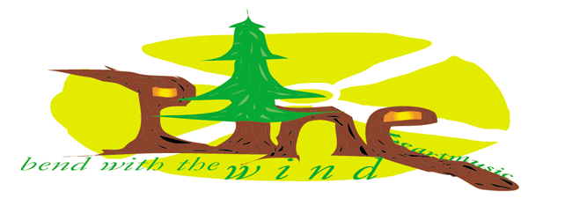

White Light
Am Fm Gm Am Capo V
Am Fm
White light, shining so bright. What do I know? What do she know-What is he?
Gm Am Dm Am Fm Gm Am
We – are children of the future. And the beat’s in our feet, Take a step step step closer to the light.

Am Fm
White light, shining so bright. What do I know? What do she know-What is he?
Gm Am Dm Am Fm Gm Am
We – are children of the spirit. Shiny moods lift like wings, Shining high soaring through the light

Am Fm
White light, shining so bright. What do I know? What do she know-What is he?
Gm Am Dm Am Fm Gm Am
We – are children of life, Shiny laughing with me. Living life dancing with the light.
Am Fm
White light, shining so bright. What do I know? What do she know-What is he?

